
Picture: Doug Gimesy

Modern Slavery Statement 2025
Melbourne Water


Table of contents
Table of contents 2
Introduction 3
About Melbourne Water 4
Structure, operations and supply chains 4
Risks of modern slavery 8
Actions taken to assess and address Modern Slavery risks 14
How we assess effectiveness 17
Consultation 19
Other information 20

Introduction
Melbourne Water Corporation (Melbourne Water) is for managing our waterways, delivering affordable and clean water to the community and keeping our people healthy with effective sewerage services.
To achieve this, Melbourne Water’s teams work with the community, developers and a wide range of stakeholders, partners and suppliers. Melbourne Water’s values are intrinsically linked to everything we do and how we engage the organisations that we work with. That’s why Melbourne Water is committed to working to ensure our operations and supply chain are free of Modern Slavery.
We have continued to enhance our systems and supplier visibility, in particular the application of the WSAA Informed 365 Modern Slavery Platform that was implemented in collaboration with other Water Authorities across Australia. This tool enables us to gain deeper insights into our supply chain and identify and address Modern Slavery risks more effectively.
This Modern Slavery Statement (the Statement) is Melbourne Water's response to the requirements of section 13 of the Australian Commonwealth Modern Slavery Act 2018 (Cwlth) (Modern Slavery Act). It has been prepared for the reporting period 1 July 2024 to 30 June 2025 (Reporting Period). Melbourne Water does not own or control any other entities in preparing this Statement.

The Statement has been approved by the Melbourne Water Board on 31 Oct 2025 and has been signed by Nerina Di Lorenzo (Managing Director) on behalf of Melbourne Water.
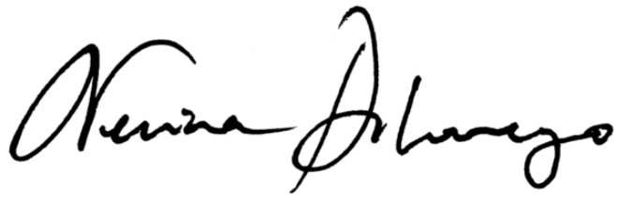

Dr Nerina Di Lorenzo
Managing Director
Melbourne Water

About Melbourne Water
The reporting entity under the Modern Slavery Act is the Melbourne Water Corporation (Melbourne Water), a water corporation established under section 85 of the Water Act 1989 (Vic).
For over 130 years, Melbourne Water has been serving the community by planning and building for our future. From providing clean drinking water, treating sewage, managing floods and drainage, and protecting our rivers, creeks and bays, we deliver the essential services that sustain our growing city today in the Port Phillip and Westernport regions.
Much of the infrastructure created over that time is still in use today—a testament to the ingenuity and foresight of those who came before us. We're delivering the essential services our city depends on today, while building the resilient, sustainable systems we need for tomorrow.
We work hard to deliver sustainable public health, financial and environmental solutions and creating opportunities for community recreation and enjoyment of the land and waterways that Melbourne Water manages. We engage and collaborate with a wide range of partners that include Melbourne’s retail water companies, councils, developers, contractors, Traditional Owners, the community, and government agencies to deliver services our customer’s value.

Structure, operations and supply chains
Melbourne Water is owned by the Victorian Government. It does not own or control other entities. The Minister for Water, in consultation with the Treasurer, appoints our Board of Directors.

Board of Directors
Our Board of Directors comprises a non-executive chairperson, eight non-executive directors and the Managing Director.

Organisational Structure
Our Managing Director oversees seven organisational portfolios with a broad range of responsibilities.
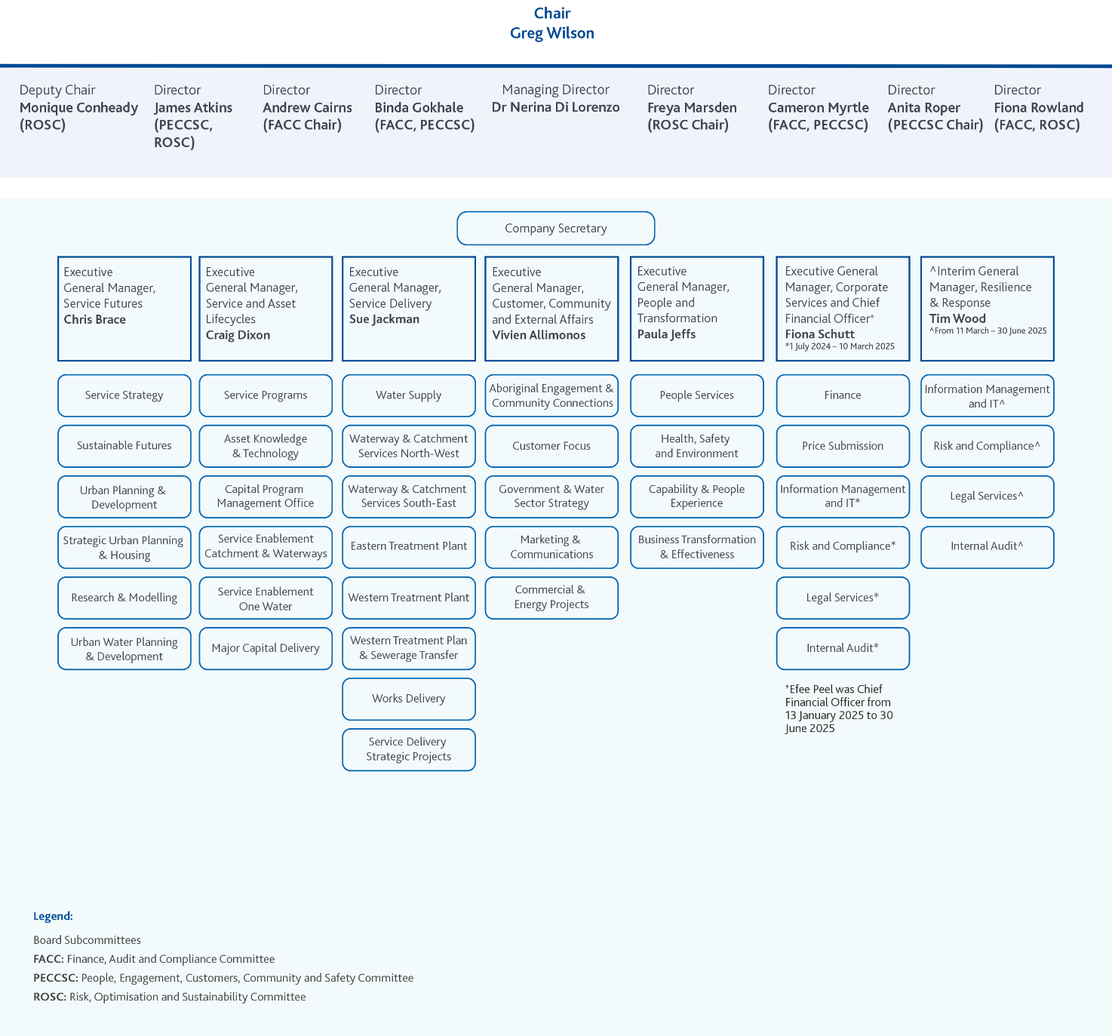

Our people
As of June 2025, Melbourne Water employed 1,469 people (1,142 full time employees, 175 part time employees and 152 fixed term and casual employees). 66% of our staff work from our head office located at Docklands in Melbourne and 34% work on operational sites including treatment plants, pumping stations, regional offices and reservoirs.
Melbourne Water has two Enterprise Agreements for employees, which provide terms and conditions, including hours of work and pay.
The Enterprise Agreements – Melbourne Water Enterprise Agreement 2024 (EA) and Melbourne Water (Waterways and Land Delivery) Enterprise Agreement 2021 (WLD EA) – are negotiated every three or four years with the respective unions, are governed by the State Government’s Industrial Relations policies and require approval from the Fair Work Commission. Both these Agreements are available to all employees upon commencement of employment and remain available through the Melbourne Water intranet. The EA covers 47% of Melbourne Water's employees and the WLD EA covers 10%. The EA 2024 came into effect during the reporting period. The WLD EA is currently going through the approval process.
Melbourne Water has separate Management Agreements that provide terms and conditions for senior and executive level employees covering 43% of Melbourne Water employees, and 0.5% are casual staff employed under casual contracts.

Operations
We are responsible for providing essential services for the Greater Melbourne region. We manage and protect:
- 10 major water storage reservoirs
- 40 service reservoirs, tanks and basins
- 13 water treatment plants
- 163,000 hectares of protected and open catchments
- 25,000 kilometres of waterways and 33,000 hectares of surrounding open space.

Water supply
Melbourne Water is dedicated to supplying affordable, high-quality drinking water to the Greater Melbourne region. We manage water supply catchments, treat and supply both drinking and recycled water products, and maintain the water transfer network. Our goal is to meet the water needs of a growing city while ensuring water quality and security.
We supply drinking water to Melbourne’s three retail water companies (Yarra Valley Water, South East Water & Greater Western Water) and other non-metropolitan water businesses which in turn provide water to households and businesses across the Melbourne region.

Sewerage treatment and resource recovery
We are also responsible for the efficient and reliable treatment of sewage for Melbourne which consists of two main treatment plants, the Western Treatment Plant at Werribee, and the Eastern Treatment Plant at Bangholme.
These two treatment plants process approximately 90% of the total sewage generated in Melbourne. A complex sewerage transfer system efficiently collects the sewage from the retail systems and transports it to one of two treatment facilities. We can then supply recycled water to wholesale customers.

Waterway and drainage management
Melbourne Water takes on the essential role of managing waterways and major drainage systems in the Port Phillip and Westernport region. This includes maintaining healthy waterways, integrated drainage management, and reducing flood risks. Together with councils we play a role in managing most of Melbourne’s drainage system.

Natural community spaces
We are committed to maintaining and preserving outstanding natural community spaces that contribute to the overall well-being of the region. These places provide recreational spaces for our community while supporting biodiversity and providing habitat for wildlife.

Supply chains
Our supply chains support the operations and key services that we provide.
We define our supply chains in terms of procurement categories and tiers. Tier 1 is our directly contracted supplier, Tier 2 represents subcontractors or suppliers to our Tier 1, and Tier 3+ represents the further upstream supply chain.
In 2024-25, Melbourne Water engaged over 2,000 Tier 1 suppliers of which 765 operate under a formal supply arrangement (contracted suppliers). From a spend perspective, contracted suppliers represent a 93% of annual spend with suppliers. Melbourne Water has procurement processes in place to undertake the most significant due diligence, setting of contractual requirements, or influencing through supplier relationships with its contracted suppliers.
We assess and manage our supply chains under the following six broad categories and sub-categories:
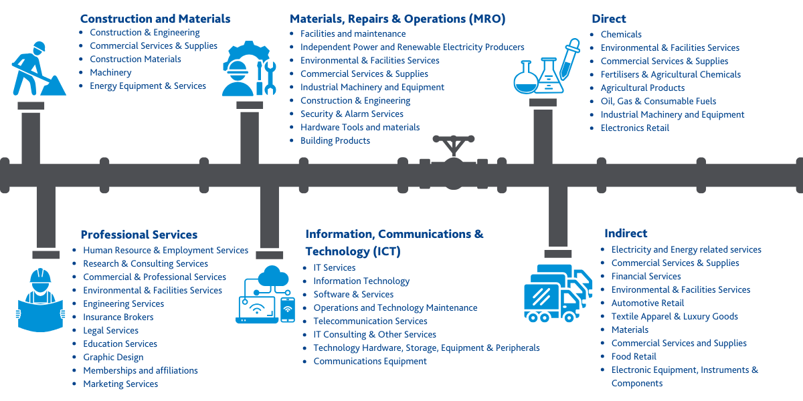

Category | Supply chain description
Construction & Materials | Melbourne Water primarily engages with large construction suppliers for the delivery of our major construction projects. We have visibility of approved subcontractors for works and core services, and the suppliers at Tier 2 for highest usage materials and components.
Materials, Repairs & Operations (MRO) | Most of our ongoing maintenance is managed by major contractors and panels of smaller contractors. We currently have visibility of approved subcontractors for key related services, and suppliers at Tier 2 for key components.
Direct | Our direct requirements are varied and support our operations. These are goods (materials/equipment/chemicals) mostly supplied by local companies drawing on a mix of locally produced and imported products or components.
Indirect | Our indirect requirements are varied. Companies located in Australia provide most of Melbourne Water’s requirement; drawing on a mix of locally produced and imported products, materials, or services.
Professional Services | Service providers delivering skilled and specialised services that support multiple aspects of our planning, design & engineering, legal, staffing, marketing, and cultural engagement. There is limited subcontracting involved and most of our engagements are through the State Purchasing Contracts (Supplier Panels) managed by the Victorian Government
Information, Communications & Technology (ICT) | ICT requirements involve hardware, software and licensing, support & maintenance services, and consulting. Melbourne Water mostly engages suppliers for ongoing ICT support through the Victorian Government supplier panels. These suppliers employ staff in Australia and overseas.

Risks of modern slavery

Operations
While our operational workforce is employed locally under fair and lawful conditions, we recognise that certain aspects of our operations may still carry risk of modern slavery, particularly where labour hire arrangements are used.

We primarily recruit temporary staff through the Victorian Government Staffing Services Panel. All suppliers in this panel hold labour hire licences in accordance with the Labour Hire Licensing Act 2018 (Vic) and the contracts are managed by the Department of Government Services.

During the reporting period, Melbourne Water engaged four staffing agencies outside of the established panel. All agencies hold valid labour hire licences. Three were engaged to provide skilled personnel in areas such as engineering and procurement, while one was utilised to support field-based trainee roles.

Supply chains
Melbourne Water may be directly linked to modern slavery practices through its supply chain, including businesses it does not directly contract with or subcontract to (e.g. Tier 3+)

During the reporting period, Melbourne Water continued to use the spend management tool Robobai to identify and categorise direct suppliers. We also used this tool to identify our direct suppliers headquartered overseas. Melbourne Water primarily procures from Australian-based entities but directly sourced supply from 31 entities based overseas in the reporting period.

Geographic risk identification
The following table provides detail on country of origin, Global Slavery Index (GSI) prevalence rank, spend range and category for overseas suppliers we engage directly (in our Tier 1).
Country | GSI Prevalence Rank | Number of suppliers | Spend Range | Supply Categories
India | 34 | 1 | $500k - $1m | Information Technology
Slovenia | 99 | 1 | Under $50k | Software & Services
United States of America | 122 | 16 | $10k - $1m | Information Technology, IT Services, Professional Services, Software & Services, Electronic Equipment, Instruments & Components
Singapore | 138 | 2 | $1k - $300k | Software & Services, Biotechnology
France | 139 | 1 | Under $50k | Software & Services
Great Britain | 145 | 7 | $10k - $500k | Information Technology, Professional Services, Software & Services, Electronic Equipment, Instruments & Components
New Zealand | 148 | 2 | $50k - $100k | Software & Services
Ireland | 153 | 1 | Under $50k | Software & Services
Total |  | 31

Supplier assessment methodology
During the reporting period, Melbourne Water has been working with technology provider Informed 365 and the Water Services Association of Australia (WSAA) to assess and address Modern Slavery risks throughout the water industry supply chains.

This collaboration allows WSAA members to assess their supply chain networks through a single online platform which collects, compares, and collates information on suppliers, to inform year-on-year progress.

This approach ensures consistency across the industry, streamlines the reporting process for businesses involved, and makes it easier for suppliers to share information with the organisations they choose. The Informed 365 tool determines Inherent Risk of Modern Slavery by combining Industry Risk data with Country Risk data from the Global Slavery Index.

Additionally, a Modern Slavery Supplier Self-Assessment Questionnaire (SAQ) has been agreed by WSAA members including weightings to each of the questions in the assessment. The SAQ allows Suppliers to provide more detail in a consistent format that provides important information on actions being taken by our Tier 1 suppliers to combat Modern Slavery, and informs our estimate of Residual Risk for links to Modern Slavery.

During the reporting period, Melbourne Water invited 180 suppliers to complete the SAQ (or publish an existing SAQ to Melbourne Water). The selection criteria for the invitations was that the supplier fit into one or more of the following criteria:
- High financial value as per Melbourne Water’s expenditure thresholds.
- Have a contract with Melbourne Water with an expiry date of 12 months or more; or
- The supplier belongs to an industry with high or very high inherent Modern Slavery risk.

106 (59%) of the invited suppliers completed the questionnaire and have shared valuable information in relation to how they manage Modern Slavery risks in their operations and supply chain. Two suppliers in the technology industry declined to complete the questionnaire and directed Melbourne Water to consult their published Modern Slavery Statements.

Category risk findings
The following table summarises our current modern slavery risk assessment by Procurement Category, using inherent risk based on Industry classification, and a supplier- level assessment integrating country risk and content of SAQ’s received:

Procurement Category and Description | Inherent Risk (global industry) | Invited suppliers | Completed SAQ | Assessed Risk including SAQ
Construction and Materials:  Construction services (minor and major projects), and materials including crushed concrete, culverts, generator and equipment hire | Medium-to-High | 20 | 9 | Very Low to Medium
Direct:  Chemicals, metres, drying and harvesting services | Medium-to-High | 8 | 5 | Low to Medium
Indirect:  Fleet Services, Energy, Waste collection, Personal Protective Equipment, Printing, revegetation plants and materials | Low-to-High | 21 | 12 | Low to Medium
ICT:  Onshore and offshore IT services, cybersecurity consulting, IT equipment, software services | Low-to-High | 54 | 29 | Very Low to Medium
MRO:  Above and underground asset maintenance, grass cutting, waterways maintenance, environmental services | Medium-to-High | 22 | 18 | Very Low to Medium
Professional Services:  Engineering Services, Staffing Services, Business consulting | Low-to-High | 55 | 33 | Very Low to Medium
 |  | 180 | 106

Supplier assessment findings – questionnaire analysis
The WSAA Self-Assessment Questionnaire aims to better understand how people may be at risk of modern slavery in the operations and supply chain of suppliers in the water sector.

The assessment was developed through consultation between the water sector organisations to ensure that common suppliers respond to a questionnaire once and also to obtain data on actions to combat modern slavery.

The following are results of the 106 questionnaires responded in Informed365

.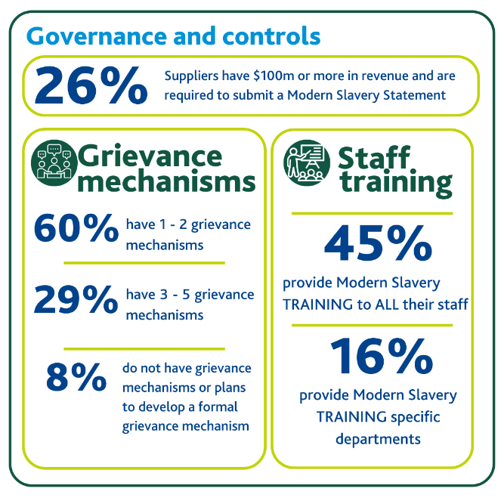 |  | Governance and controls questions allow Melbourne Water to understand the obligations that our suppliers have to comply with the Modern Slavery Act 2018 and any tangible actions our suppliers are taking to ensure their employees, contractors and suppliers understand their rights and have grievance mechanisms to ensure their voices are heard, if their rights are not being respected.  Key findings in governance and controls:  - A quarter of our suppliers have obligations to report through a Modern Slavery Statement to the Attorney General. Therefore, three quarters of our respondents report their risks and actions through this questionnaire.  - The majority of respondents have at least 1 grievance mechanism available to their employees.  - Over half of respondents have provided modern slavery training to either all their staff or specific departments. For the suppliers that do not provide training, 14% have plans to provide it in the next 12 months and 17% don’t have plans to provide training.
Employment conditions questions help determine whether suppliers are identifying and managing modern slavery risks caused by employment of vulnerable cohorts (for example, migrants, low skilled roles).  For the reporting period:  - All respondents stated to comply with the law in terms of rights and employee due diligence.  - Where suppliers recruit personnel from overseas, they verify employee eligibility and are provided with written contracts.  - Only 2 out of the 106 respondents have used both licensed and unlicensed labour hire providers. |  |  |  | 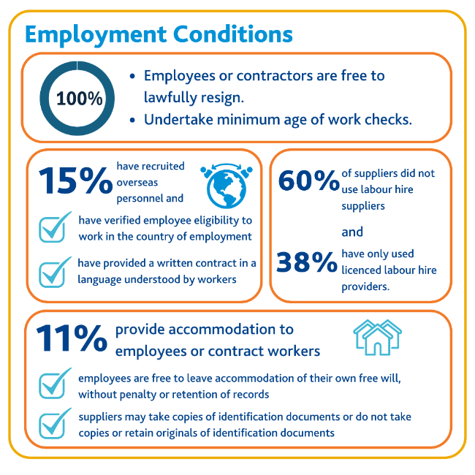
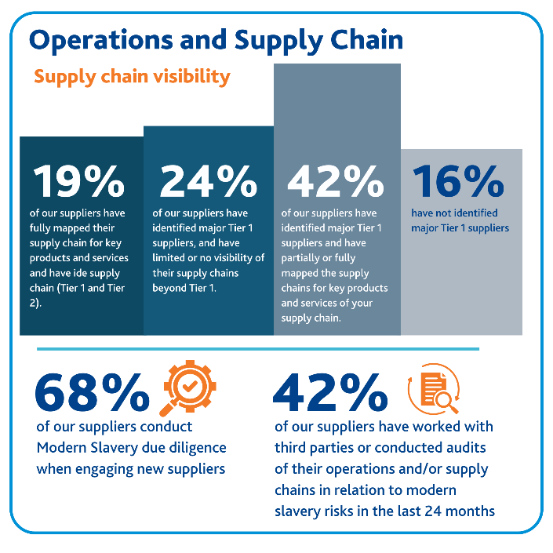 |  | Visibility across supply chains remains mixed. While the majority of our suppliers have identified major Tier 1 suppliers and have started efforts into mapping their supply chain, only a fifth of respondents have fully mapped their supply chain at Tier 1 and Tier 2 levels.  - A minority of our suppliers reported to have suppliers in high risk countries and 13% remain unsure.  - A minority of suppliers also belongs to industries with inherent high risk of modern slavery such as: metals, steel and mining, textiles, and agricultural materials.  - During the reporting period, 2 suppliers stated to have found instances of modern slavery in their supply chain. Both suppliers are mandated to report a Modern Slavery Statement to Attorney General. Upon further investigation, only one supplier had found instances beyond their Tier 2 suppliers and is currently working on remediating the issue.
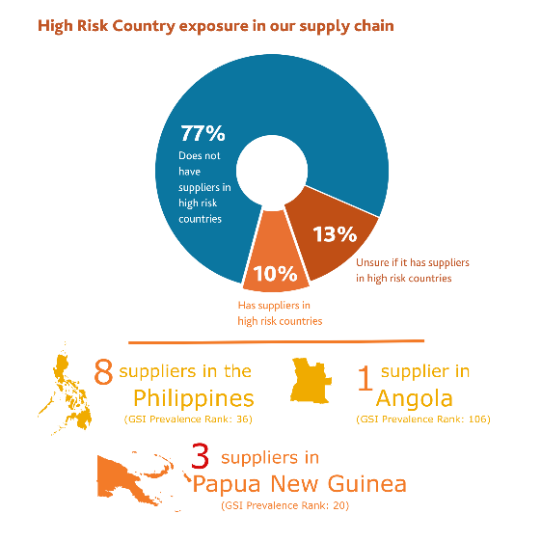 | 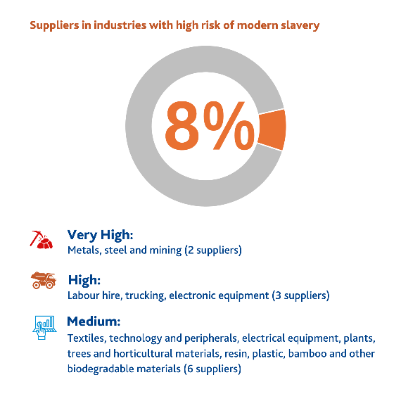 |  | 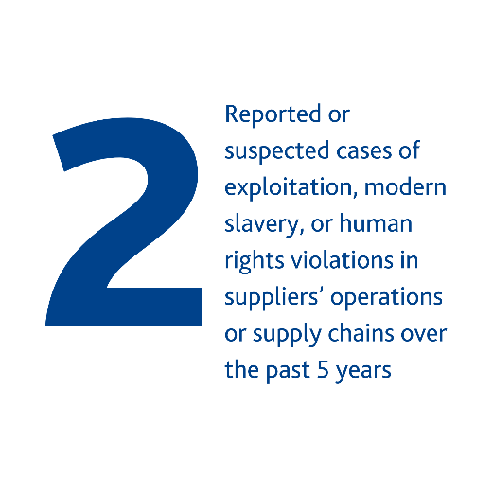 |  | 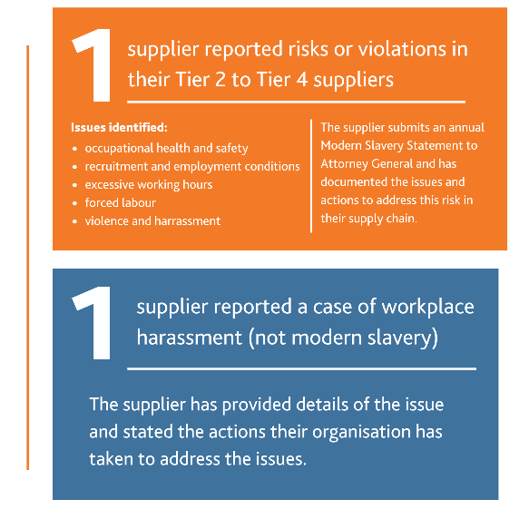

Actions taken to assess and address Modern Slavery risks

Operations
Melbourne Water has established policies and procedures to foster a respectful workplace and address employee grievances and concerns. While these policies and procedures are not exclusively tailored for Modern Slavery risk management, they do provide mechanisms for Melbourne Water employees to report, monitor, and address labour-related complaints and grievances.

Respectful Workplace Policy
Melbourne Water upholds a comprehensive Respectful Workplace Policy, designed to cultivate an inclusive work environment that is devoid of bullying, discrimination, and harassment. This policy commits to eradicating all forms of inappropriate behaviour, including discrimination, harassment, sexual harassment, occupational violence, bullying, and victimization. Any violations of this policy are investigated and managed in accordance with Melbourne Water's Human Resource Complaint Resolution Procedure.

Employee Assistance Programme (EAP)
Melbourne Water provides an Employee Assistance Programme (EAP) accessible to all employees and their immediate families. This resource offers confidential support and guidance, fostering a healthy work environment and assisting employees in navigating personal challenges.

STOPline Reporting
Melbourne Water offers an independent and confidential reporting mechanism known as STOPline. This hotline empowers employees and contractors to report instances of improper conduct and breaches of the Code of Conduct.

STOPline was enhanced during 2023-24 to include the capability to report suspected cases of Modern Slavery and this is being maintained.

Our intranet and the STOPline website both provide comprehensive information on indicators of Modern Slavery, guiding individuals to report their concerns. Reporting can made by responding to a series of questions, with the option to disclose personal details or remain anonymous.

Supply Chain

Governance and procurement practices
Our procurement follows the policies of the Victorian Government Purchasing Board (VGPB), the Ministerial Directions and Instructions for Construction Procurement, and our own Procurement Policy and Framework. These guide our activities to ensure our buying power advances social, economic, and environmental objectives. As a Victorian Government-owned organisation, we aim to ensure our purchases represent value for money and are sourced fairly and ethically.
At Melbourne Water, the responsibility for coordinating and managing Modern Slavery risks along supply chains lies within the Procurement and Contract Management team. A key focus of the governance lens captures modern slavery risk across the following functional streams:

Function | Modern Slavery specific activity
Category management | Planning: Identifying Modern Slavery risks of each category and subcategory prior to approaching the market.
Sourcing delivery | Due Diligence: Evaluating specific supplier Modern Slavery risk and mitigation actions prior to contracting with a supplier.
Contract management | Ongoing monitoring and remediation: Assessing ongoing effectiveness of agreed terms.
ESG management | Oversee and manage strategies in respect to Modern Slavery through procurement and contract environments.
Governance | Develop and implement policies, tools, and systems to ensure robust and compliant procurement processes. The Governance team manages the spend management tool (Robobai), the supplier assessment tool (WSAA Informed 365 Modern Slavery Platform) and our contract register tool (Zycus).

Third Party Risk Management Framework
During the reporting period, Melbourne Water has continued to use its Third Party Risk Management Framework which documents the appropriate due diligence and risk management strategies to manage risks brought to Melbourne Water by third parties, including our suppliers. The framework covers all stages of the procurement life cycle, from planning to sourcing to contract management.

Supplier Code of Conduct
All Melbourne Water tendering activity requires vendors to commit to the Victorian Government Supplier Code of Conduct (the Code).

The Code describes the minimum standards that our Suppliers must achieve, in order to establish and maintain a business relationship with Victorian government agencies. Specifically it covers:
• respect the rights and entitlements of their personnel;
• provide a fair and ethical workplace, free from discrimination, workplace bullying, harassment, victimisation and abuse; and
• act against human rights exploitations and make all reasonable efforts to actively support the elimination of modern slavery by identifying and mitigating modern slavery risks along their supply chain.
During this reporting period the application of the Code has been updated from a process of obtaining a letter of commitment in tenders, to incorporating as a contractual requirement.

Subcontractor management in infrastructure projects
Melbourne Water currently works with a cohort of major service providers for construction and infrastructure maintenance. Due to the nature of the services and the requirement of Victorian Government policies, frameworks and codes such as Local Jobs First (LJF), Social Procurement Framework, Fair Jobs Code and Supplier Code of Conduct - which are all integrated into Melbourne Water's procurement procedures. Typically, major contractors must report on type and number of employees and number of hours for specific roles, as well as expenditure with Tier 2 suppliers/subcontractors. While the purpose of these policies is variously socio-economic, e.g. local jobs retention/creation, training & skills development, boosting social impact, or ensuring ethical employment standards: service provider compliance with these policies indirectly mitigates Modern Slavery risk as a result of the monitoring and reporting requirements contained within the policies.
In addition to the above, Melbourne Water contractually requires Tier 1 contractors to nominate and obtain approval to use subcontractors; and to acknowledge and sign a statutory declaration to confirm that workers and subcontractors have been paid in accordance with the law.
Additional due diligence checks are undertaken by the Fair Jobs Code Unit of Department of Government Services when they prepare Fair Jobs Code Pre-Assessment Certificates – which are generally required for major contractors and significant subcontractors.

WSAA Informed 365 Modern Slavery Platform
As outlined in the ‘Risks of Modern Slavery’ section, Melbourne Water utilises the WSAA Informed 365 Modern Slavery Platform to gain deeper insight into the maturity and progress of our suppliers in addressing modern slavery risks within their supply chains. Supplier responses provide valuable data, enabling Melbourne Water to identify high risk areas and determine where further engagement or action may be required. Where responses indicate potential concerns or gaps, Melbourne Water initiates follow-up discussions to seek clarification and assess appropriate next steps (if any).

Training
During the reporting period, modern slavery awareness training, focused on the Procurement and Contract Management was further developed and training extended to more staff involved in procurements throughout the organisation.

How we assess effectiveness

Key Performance Indicators
During the last reporting period, Melbourne Water engaged a consultant to develop a Third Party Risk Management Framework in which Modern Slavery is set as part of the supply chain integrity risk domain. The following key performance indicators (KPIs) have been set to monitor our progress in assessing Modern Slavery risk and further developing our management capability to more effectively address that risk.
KPI | Purpose
1. Modern Slavery questionnaire completion rate  Measures completion rates by suppliers within WSAA Informed 365 Platform | Assessing our suppliers operations and supply chain is the initial step to better understand our modern slavery risks.  The platform is also used to offer anti-slavery guidance to the respondents.  KPI tracks the level of engagement of suppliers and coverage of supply chain assessed via the platform
2. Contracts with Modern Slavery clauses  Measures proportion of new contracts that use standardised Modern Slavery clauses (excludes sub-agreements to existing panel agreements) | Melbourne Water contract templates include modern slavery clauses that require suppliers to take steps to identify, prevent, and address risks of modern slavery in their operations and supply chains and include obligations around due diligence, reporting, and cooperation with audits or investigations.  Contracts based on vendor terms may not have consistent obligations on modern slavery. This limits our ability to ensure appropriate coverage and accountability across these engagements
3. Alleged incidents of Modern Slavery  Measures alleged modern slavery incidents reported through StopLine | Tracking incidents or allegations of modern slavery involving our operations or supply chain
4. Modern Slavery training  Measures number of Melbourne Water staff trained on Modern Slavery risk issues | Monitor roll-out of internal education to staff on the topic of Modern Slavery and the risk mitigation methods available.
KPI 1 – Modern Slavery questionnaire completion rate
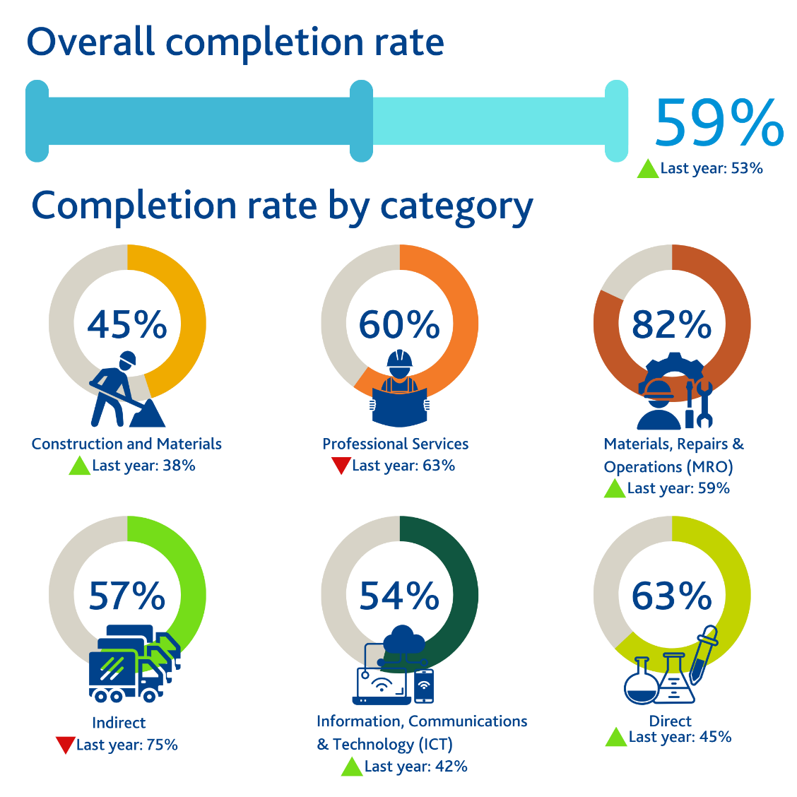
This year, our overall completion of the questionnaire is up by 6% compared to last year. We expect to increase this number as more contracts have the requirements for vendors to complete the Modern Slavery questionnaire.

KPI 2 – Contracts with Modern Slavery clauses
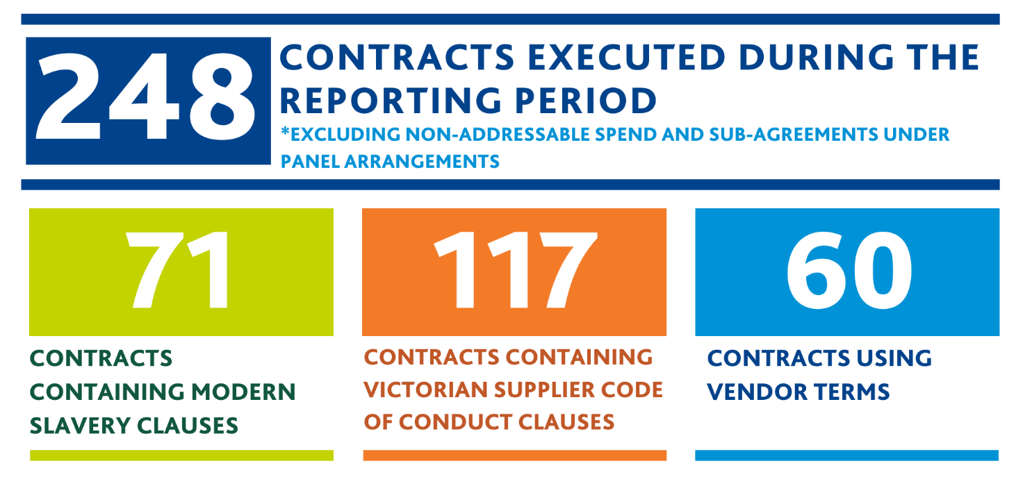
KPI 3 – Alleged instances of Modern Slavery | 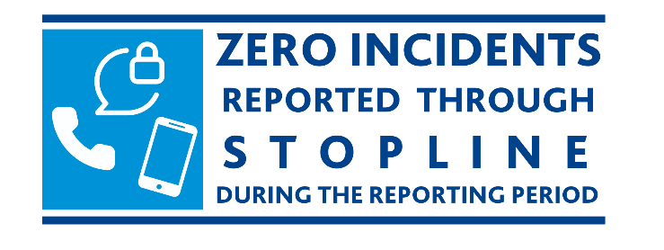
Unchanged from last year
KPI 4 – Modern Slavery Training | 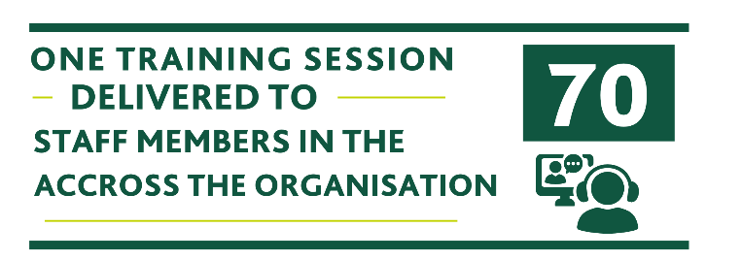
Up from 20 last year

Consultation
Melbourne Water does not own or control any other entities.

Other information

Working Group
Melbourne Water continues to collaborate with other water authorities to drive continuous improvement and share insights on identifying, addressing, and reducing modern slavery risks across our operations and supply chain.

Challenges
Melbourne Water acknowledges the growing challenge of supplier fatigue in response to modern slavery reporting questionnaires from multiple clients.

While our current Modern Slavery tool has significantly increased the volume of available data from our supply chain and provides access to resources, we recognise that questioning our suppliers about their operations and supply chain is only a step in combating modern slavery in the supply chain, and engagement is more effective when it is targeted.

To improve the impact of our efforts, we are reviewing our engagement strategy to focus on suppliers operating in higher-risk industries and where Melbourne Water has greater commercial leverage or long-term relationships. This approach should allow us to allocate internal resources more effectively and influence more meaningful change within our supply chain.

Looking forward
For the year ahead, we aim to focus on deepening our understanding and due diligence on Tier 2 and beyond for suppliers in high risk categories.

Also, we aim to further develop training materials for staff on how to respond to an allegation of modern slavery in our supply chain, prioritising the wellbeing of the impacted person.

Global Slavery Index, Maps | Global Slavery Index
The Local Jobs First Policy requires Victorian Government Entities to procure goods, services and/or construction from businesses that create local jobs opportunities, including apprentices, trainees, and cadets. Suppliers required to comply with this policy provide employment data to the Victorian Government through a specifically designed portal. The Local Jobs First Commissioner may request an audit on a specific project to any Victorian Government Entity.
Social Procurement is when organisations use their buying power to generate social value above and beyond the value of the goods, services or construction being procured. Victorian State Government entities are required to apply the Social Procurement Framework (SPF).

